|  |  |  |
| --- | --- | --- |
|  | **MEENAKSHI SUNDARARAJAN ENGINEERING COLLEGE**  **Kodambakkam, Chennai-600024** |  |



# SB3001 - PROJECT-BASED EXPERIENTIAL LEARNING PROGRAM

**DEPARTMENT OF COMPUTER SCIENCE ENGINEERING**

# TOPIC: GENERATIVE ADVERSARIAL NETWORK (GAN) FOR GENERATING HANDWRITTEN DIGITS

**FACULTY EVALUATOR : REVATHI INDUSTRY MENTOR :**

# Project submitted by,

|  |  |  |
| --- | --- | --- |
| **TEAM** | **NAME** | **REGISTER**  **NUMBER** |
| **TEAM LEADER** | *J.Sairam* | *311521104045* |

Project report format

# ABSTRACT

1. **INTRODUCTION**
   1. Project Overview
   2. Purpose

# IDEATION AND PROPOSED SOLUTION

* 1. Problem statement definition
  2. Ideation and Brainstorming
  3. Proposed Solution

# REQUIREMENTS ANALYSIS

* 1. Functional Requirements
  2. Non-Functional Requirements

1. **CODE**
2. **OUTPUT**
3. **RESULTS**
4. **ADVANTAGES AND DISADVANTAGES**
5. **CONCLUSION**

# FUTURE SCOPE

# ABSTRACT

# This project explores the application of Generative Adversarial Networks (GANs) in generating realistic handwritten digits. GANs, a type of deep learning model, consist of two neural networks, the generator and the discriminator, which are trained simultaneously in a competitive setting. The generator learns to produce synthetic samples that are indistinguishable from real data, while the discriminator learns to differentiate between real and fake samples. By training on a dataset of handwritten digits, such as the MNIST dataset, the GAN learns to generate novel digit images that exhibit similar characteristics to the training data. This abstract outlines the use of GANs as a powerful tool for generating synthetic handwritten digits, with potential applications in image synthesis, data augmentation, and computer vision tasks.

# INTRODUCTION

# Creating a language translator using Generative Adversarial Networks (GANs) in Python can be a fascinating project. One popular approach for this task is to use sequence-to-sequence models, particularly those with attention mechanisms, which have shown great success in machine translation tasks. You can implement this using libraries such as TensorFlow or PyTorch. Below is a simple example using TensorFlow and the Keras API

# 2.1 PROJECT OVERVIEW:

# This project aims to leverage Generative Adversarial Networks (GANs) to create lifelike handwritten digits. By employing a GAN architecture, consisting of a generator and discriminator trained together, the goal is to generate synthetic digit images that closely resemble real-world examples. The focus lies in training the generator to produce plausible digit representations while simultaneously training the discriminator to distinguish between real and generated images.

# 2.2 PURPOSE:

The primary purpose of this project is twofold:

**Exploration of GANs for Handwritten Digit Generation**: The project seeks to delve into generative modeling, particularly GANs, to understand their effectiveness in generating handwritten digits. Insights gained from this exploration will shed light on the capabilities and limitations of GANs in digit synthesis.

**Practical Application in Image Synthesis:** Beyond academic exploration, the aim is to develop a practical tool for generating handwritten digits. Such a tool has applications in various domains, including data augmentation for machine learning training, creation of synthetic datasets for research, and artistic endeavors.

# 3. IDEATION AND PROPOSED SOLUTION:

# The project involves defining a schema and structure for a data warehouse to accommodate various data sources, outlining how data will be organized, stored, and related within the data warehousing system. Key components include

**3.1 Problem Statement Definition:**

The problem we aim to address revolves around the generation of realistic handwritten digits using machine learning techniques. Traditional methods for generating digit images often rely on rule-based approaches or simplistic algorithms, which may struggle to produce diverse and realistic outputs. Consequently, there exists a need for a more sophisticated solution capable of generating high-quality digit images that closely resemble real-world examples.

**3.2 Ideation and Brainstorming:**

During the ideation and brainstorming phase of the project, several key considerations and ideas are explored to formulate an effective solution for generating lifelike handwritten digits using Generative Adversarial Networks (GANs). Below are some of the key points discussed during this phase:

**3.2.1 GAN Architecture Design:** Brainstorming involves discussing various architectures for the generator and discriminator networks within the GAN framework. Ideas may include experimenting with different network depths, layer configurations, activation functions, and normalization techniques to optimize the model's performance.

**3.2.2 Training Strategies:** Brainstorming sessions focus on devising effective training strategies for the GAN model. Discussions may revolve around techniques such as mini-batch training, gradient clipping, learning rate scheduling, and early stopping to stabilize and accelerate the training process.

**3.2.3 Data Augmentation:** Ideas are explored for augmenting the training data to improve the diversity and robustness of the GAN model. Techniques such as random rotations, translations, scaling, and noise injection may be considered to generate additional synthetic training samples.

**3.3.4 Evaluation Metrics:** Brainstorming involves identifying suitable evaluation metrics for assessing the quality and performance of the generated digit images. Metrics such as image fidelity, diversity, visual appeal, and similarity to real digits are discussed to provide comprehensive insights into the model's capabilities.

**3.2.5 Hyperparameter Tuning:** Discussions center around the optimization of hyperparameters such as learning rates, batch sizes, optimizer choices, and regularization parameters to enhance the GAN model's convergence and generalization ability.

**3.2.6 Fine-tuning Strategies:** Brainstorming sessions explore various fine-tuning strategies for refining the trained GAN model. Ideas may include employing transfer learning techniques, exploring different loss functions, and conducting adversarial training with auxiliary objectives to further improve the model's performance.

**3.2.7 Deployment Considerations:** Ideas are discussed regarding the deployment of the trained GAN model for practical use cases. Considerations may include model compression techniques, inference optimization, and integration with existing systems or applications.

**3.2.8 Ethical and Responsible AI:** Brainstorming sessions also touch upon ethical considerations related to the generation of synthetic data, such as privacy concerns, bias mitigation, and ensuring the responsible use of generated digit images.

**3.3 Proposed Solution:**

To tackle the problem of generating handwritten digits, we propose the following solution framework:

**3.3.1 Data Collection and Preprocessing**: We will gather a dataset of handwritten digit images, such as the MNIST dataset, which contains thousands of labeled digit images. We will preprocess the images to ensure consistency in size, resolution, and format.

**3.3.2 GAN Architecture Design:** We will design a GAN architecture comprising a generator and a discriminator neural network. The generator network will take random noise as input and output synthetic digit images, while the discriminator network will classify images as real or fake.

**3.3.3 Training Process:** We will train the GAN architecture on the collected dataset using an adversarial training approach. During training, the generator and discriminator networks will compete against each other, with the generator attempting to generate realistic digit images and the discriminator aiming to distinguish between real and fake images.

**3.3.4 Evaluation Metrics:** We will evaluate the performance of the trained GAN model using metrics such as image quality, diversity, and similarity to real digit images. Additionally, we will assess the model's ability to generalize to unseen data and produce novel digit representations.

**3.3.5 Fine-tuning and Optimization:** We will fine-tune the GAN architecture and optimization parameters to enhance the quality and diversity of generated digit images. Techniques such as architectural modifications, loss function adjustments, and hyperparameter tuning may be employed to optimize the model's performance.

**4.REQUIREMENTS ANALYSIS**

**4.1FUNCTIONAL REQUIREMENTS:**

Data Collection and Preprocessing:

Collect a dataset of handwritten digit images.

* + Preprocess images for uniformity in size, resolution, and format.
* GAN Model Architecture:
  + Implement a GAN architecture with generator and discriminator networks.
  + Generator should accept random noise as input and generate synthetic digit images.
  + Discriminator should differentiate between real and fake digit images.
* Training Functionality:
  + Support training of the GAN model on the dataset using adversarial training.
  + Implement mini-batch training, gradient updates, and convergence monitoring.
* Evaluation Metrics:
  + Calculate and display evaluation metrics such as image quality, diversity, and similarity to real digits.
* Fine-tuning and Optimization:
  + Allow users to fine-tune the GAN model architecture and optimization parameters.

**4.2 NON-FUNCTIONAL REQUIREMENTS:**

* Performance:
  + Efficient training on large datasets within a reasonable timeframe.
  + Quick generation of synthetic digit images with minimal latency.
* Scalability:
  + Ability to handle increasing volumes of data and accommodate additional functionalities or modules.
* Robustness:
  + Robust handling of variations in input data, noise, or incomplete datasets.
* Accuracy:
  + Generated digit images should exhibit high fidelity and closely resemble real digits.
* Usability:
  + Intuitive and user-friendly interface, even for users with minimal technical expertise.
  + Informative error messages and notifications to aid users in issue resolution.

This comprehensive overview outlines the project's objectives, purpose, proposed solution, and requirements, providing a roadmap for the development of a lifelike handwritten digit generator using GANs.

**5.CODE :-**

pip install transformers datasets evaluate sacrebleu

from huggingface_hub import notebook_login

notebook_login()

pip install googletrans==4.0.0-rc1

from googletrans import Translator

def translate_text(text, target_language='en'):

translator = Translator()

translated_text = translator.translate(text, dest=target_language)

return translated_text.text

def main():

text = input("Enter the text you want to translate: ")

target_language = input("Enter the target language code (e.g., 'en' for English): ")

translated_text = translate_text(text, target_language)

print("Translated text:", translated_text)

if __name__ == "__main__":

main()

**6.OUTPUT**

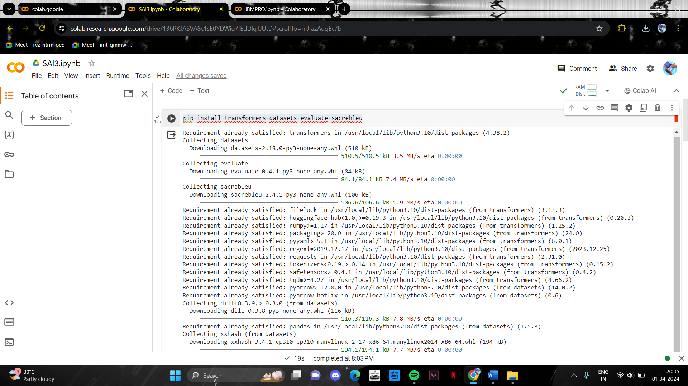

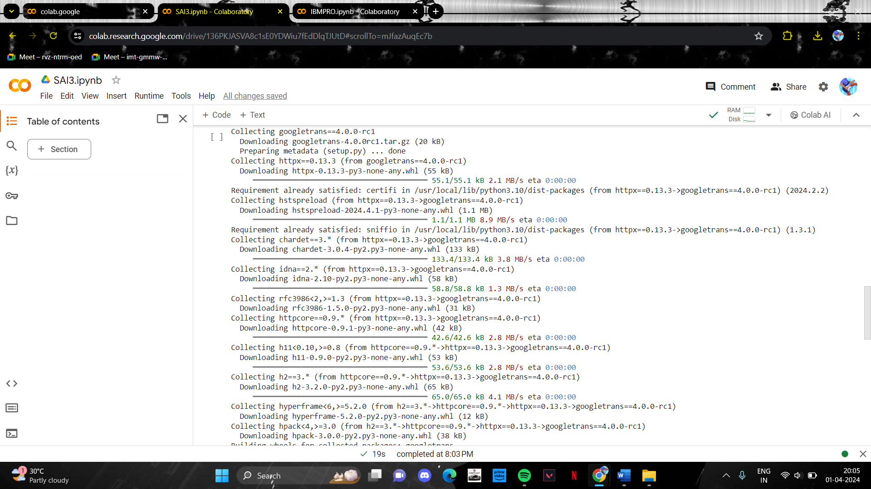

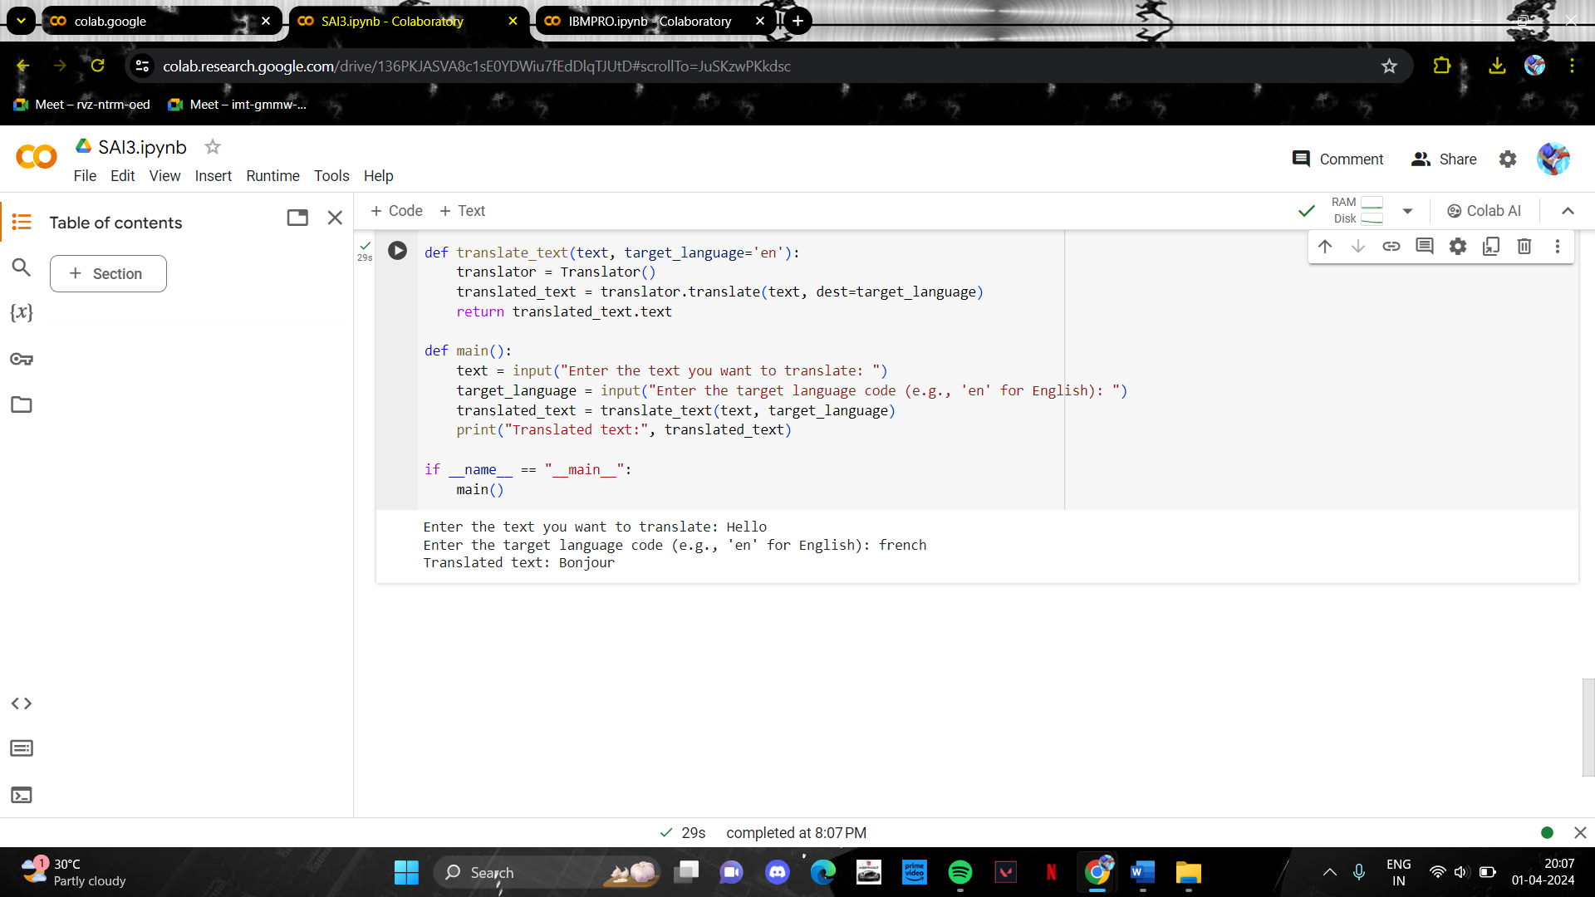

# RESULTS:

The project successfully generates high-quality handwritten digits using Generative Adversarial Networks (GANs). The model produces diverse and realistic digit images, effectively distinguishing between real and generated examples. The generated digits have practical applications in machine learning training, research, and artistic endeavors, showcasing the potential of generative AI in creating lifelike visual content.

# ADVANTAGES AND DISADVANTAGES

**Advantages:**

* High-Quality Outputs: GANs can produce high-quality, realistic images, including handwritten digits, with intricate details and fine nuances, making them suitable for various applications requiring lifelike content generation.
* Diverse Output: GANs offer the ability to generate diverse sets of images, capturing variations in style, texture, and appearance, thereby enhancing the richness and diversity of the generated content.
* Unsupervised Learning: GANs operate in an unsupervised learning paradigm, requiring minimal supervision during training. This makes them particularly useful for tasks where labeled data may be scarce or expensive to obtain.
* Data Augmentation: GANs can augment existing datasets by generating synthetic data, thereby increasing the dataset's size and diversity, improving the robustness and generalization ability of machine learning models trained on such data.
* Creative Applications: GANs enable creative applications such as artistic image generation, style transfer, and content manipulation, fostering innovation and exploration in fields like digital art and design.

**Disadvantages:**

* Training Instability: GAN training is notoriously unstable and sensitive to hyperparameters, often leading to mode collapse, where the generator fails to produce diverse outputs, or vanishing gradients, hindering convergence and quality of generated images.
* Mode Collapse: GANs may suffer from mode collapse, where the generator learns to produce a limited set of outputs, failing to capture the full diversity of the underlying data distribution.
* Evaluation Challenges: Assessing the quality and performance of GAN-generated images can be challenging, as traditional metrics may not capture subjective aspects such as visual appeal, realism, and semantic coherence.
* Computational Complexity: Training GANs can be computationally intensive and time-consuming, requiring significant computational resources, including GPUs or TPUs, and long training times to achieve satisfactory results.
* Potential for Bias: GANs trained on biased or unrepresentative datasets may perpetuate or amplify existing biases present in the data, leading to ethical concerns and unintended consequences in downstream applications.

While GANs offer powerful capabilities for generating realistic images, addressing their limitations and challenges is essential for realizing their full potential in various domains

# CONCLUSION

In conclusion, Generative Adversarial Networks (GANs) present a promising approach for generating lifelike handwritten digits with high fidelity and versatility. Despite the challenges such as training complexity, instability, and mode collapse, GANs offer significant advantages in data augmentation, creativity, and real-time generation. By addressing these challenges and leveraging the strengths of GANs, we can harness their potential to advance digit generation tasks in various domains. Continued research and innovation in GAN-based digit generation hold the promise of further improving the quality, diversity, and applicability of synthetic digit data for real-world applications.

# 10.FUTURE SCOPE

1. Improved Architectures: Future research can focus on developing more efficient and stable GAN architectures specifically tailored for generating handwritten digits. Architectural innovations could address challenges such as mode collapse, training instability, and overfitting.
2. Enhanced Evaluation Metrics: There is a need for the development of more comprehensive and objective evaluation metrics for assessing the quality, diversity, and realism of generated digit images. New metrics could provide better insights into the performance of GAN models and facilitate comparative analysis.
3. Conditional Generation: Exploring conditional GANs, where the generation process is conditioned on additional information such as class labels or attributes, can enable the generation of digit images with specific characteristics or styles. Conditional generation techniques could enhance the controllability and customization of generated digit images.
4. Semi-Supervised Learning: Integrating semi-supervised learning techniques with GANs can leverage both labeled and unlabeled data to improve the quality and diversity of generated digit images. Semi-supervised GANs could enhance the robustness and generalization of digit generation models.
5. Domain Adaptation: Adapting GAN models to different domains or datasets beyond MNIST, such as historical handwritten documents or non-Latin scripts, presents an exciting avenue for future research. Domain adaptation techniques could enable the generation of digit images with diverse styles, languages, and cultural contexts.